AI ASSISTED CODING
ASSINGMENT -4
NAME:K.POORNACHANDER
HALL.NUMBER:2403A52382
BATCH:AI 14
Task #1 – Zero-Shot Prompting with Conditional Validation
Objective
Use zero-shot prompting to instruct an AI tool to generate a function that validates an Indian mobile number.
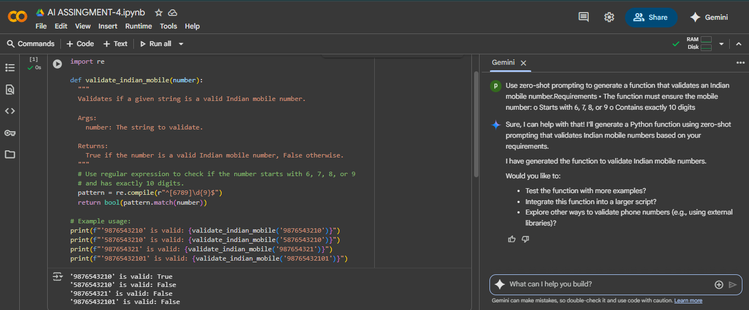
EXPLANITION:
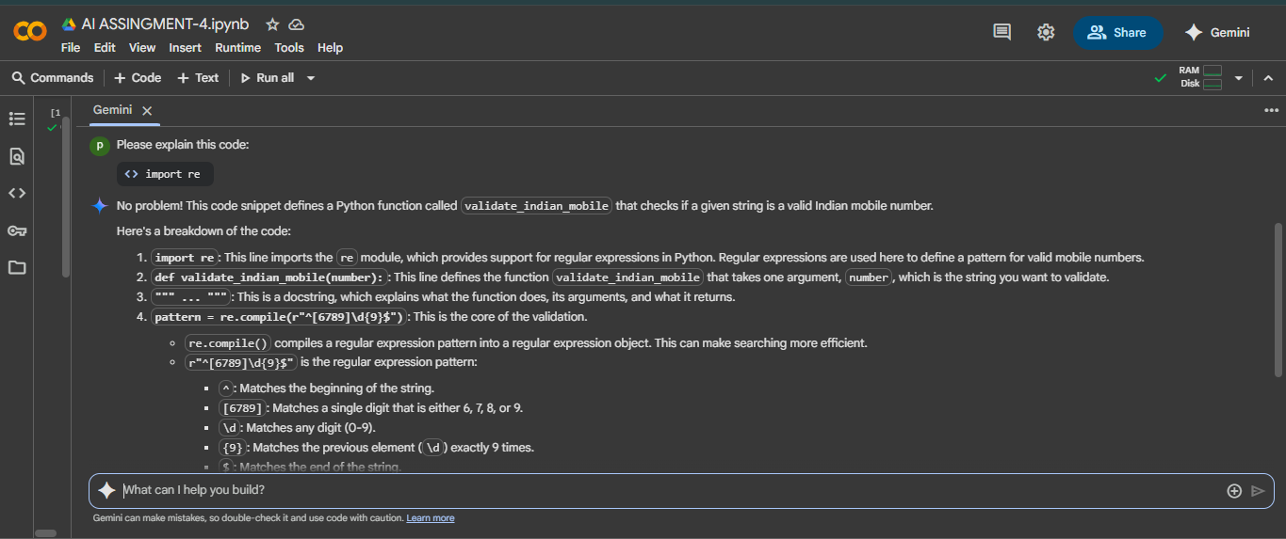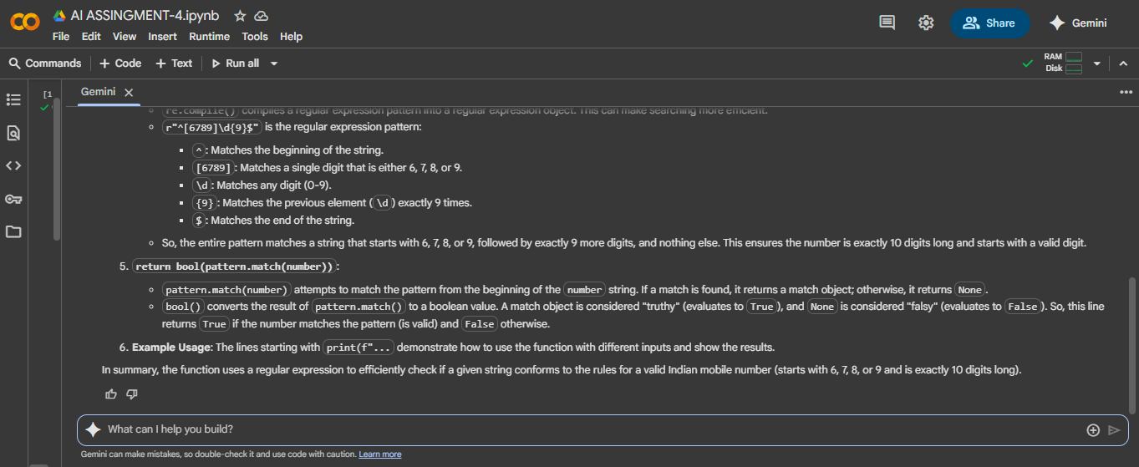
Task #2 – One-Shot Prompting with Edge Case Handling
Objective
Use one-shot prompting to generate a Python function that calculates the factorial of a number.
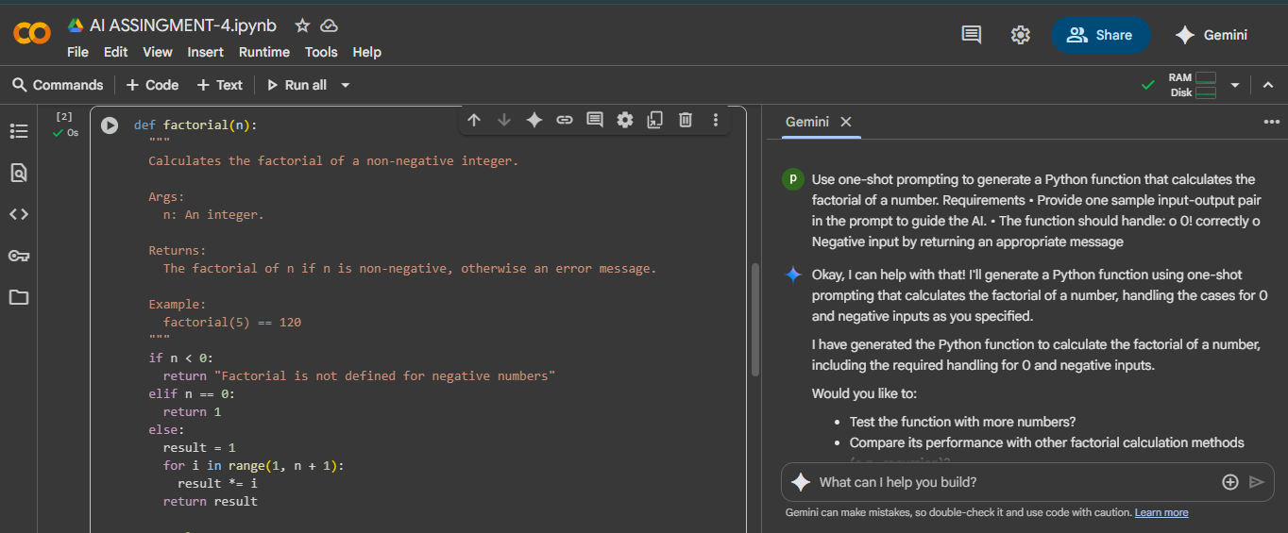
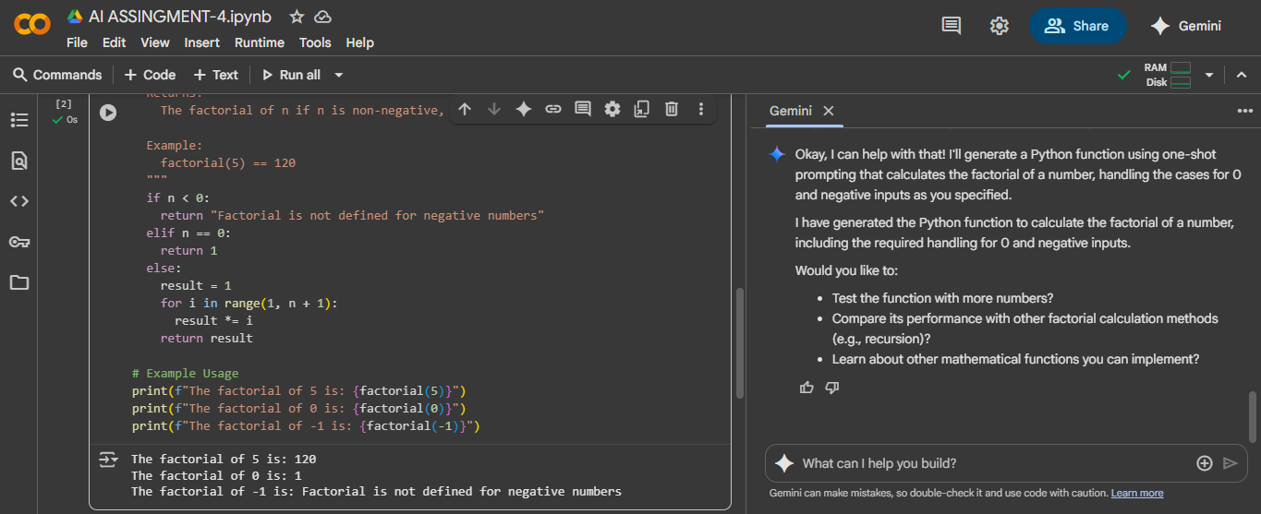
EXPLANITION:
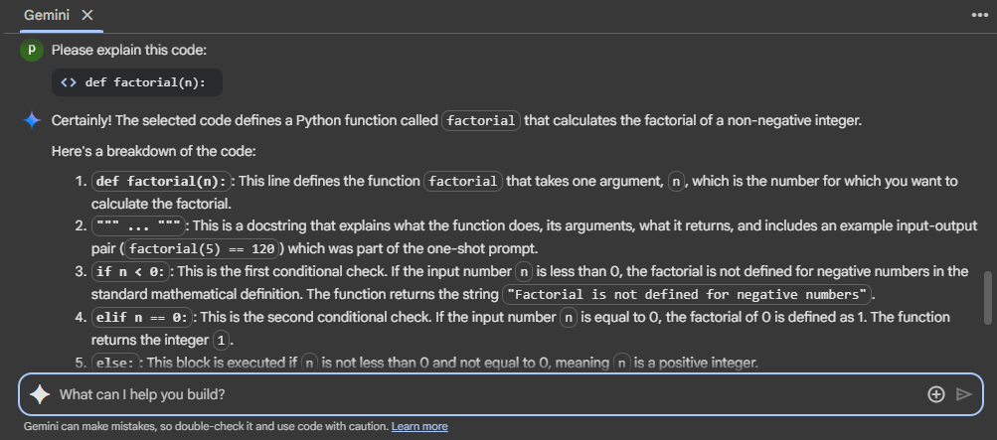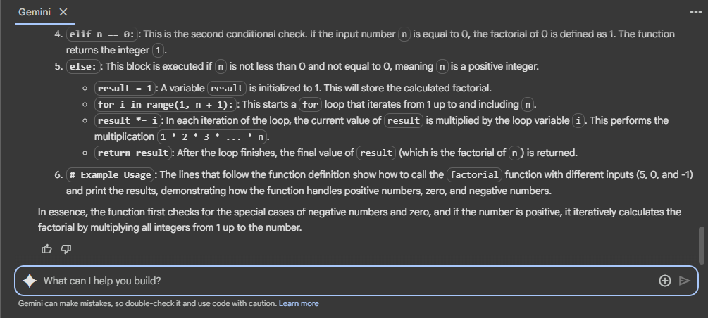
Task #3 – Few-Shot Prompting for Nested Dictionary Extraction
Objective
Use few-shot prompting (2–3 examples) to instruct the AI to create a function that parses a nested dictionary representing student information.
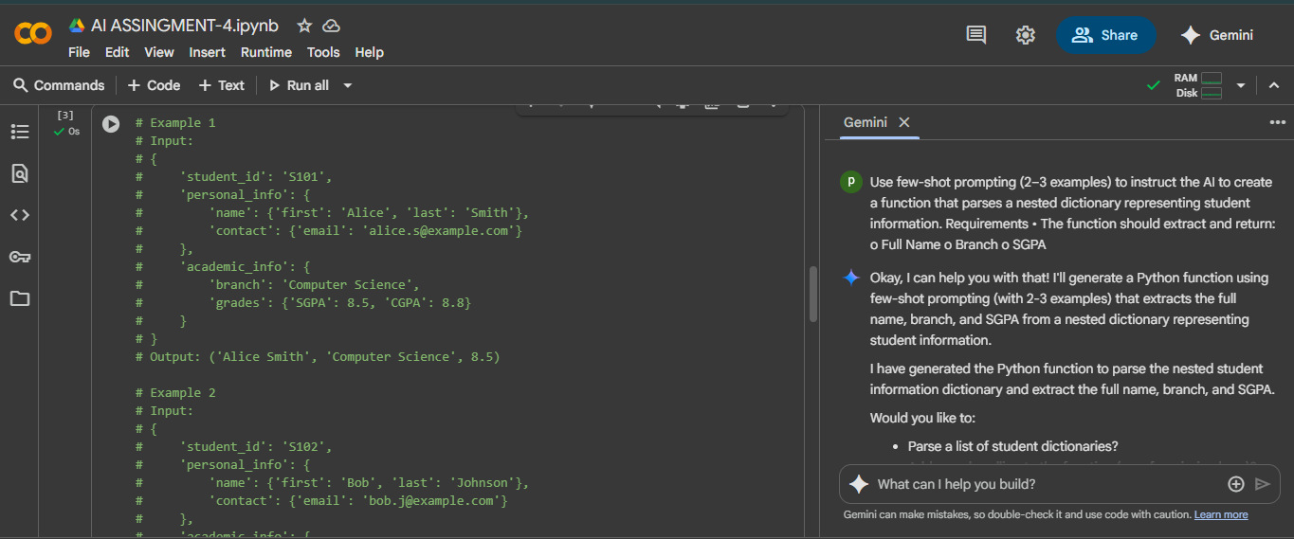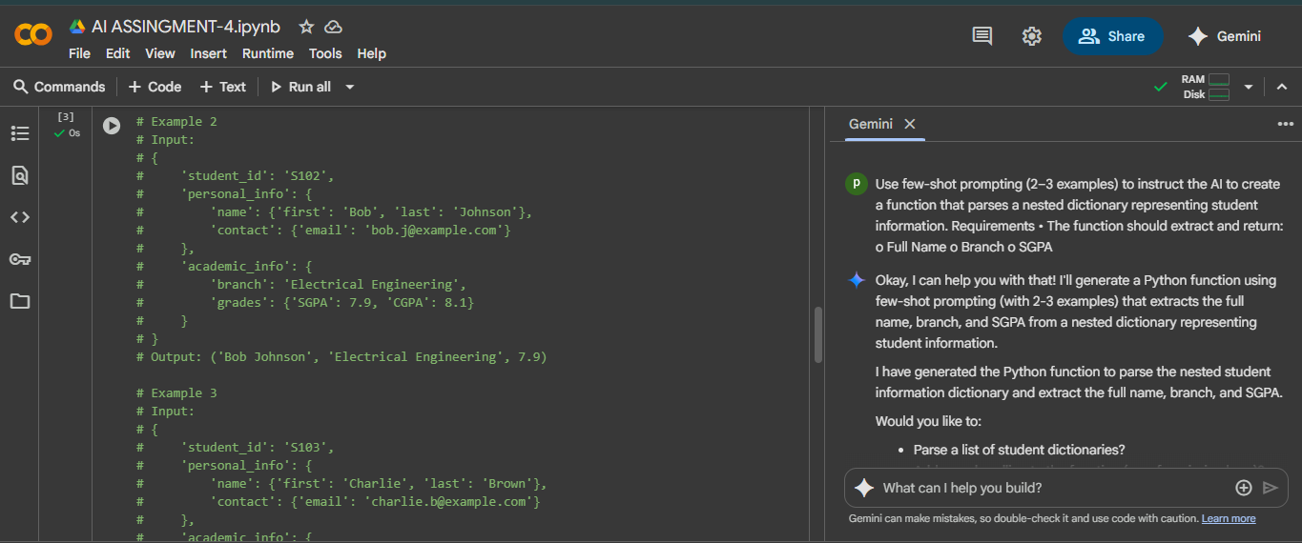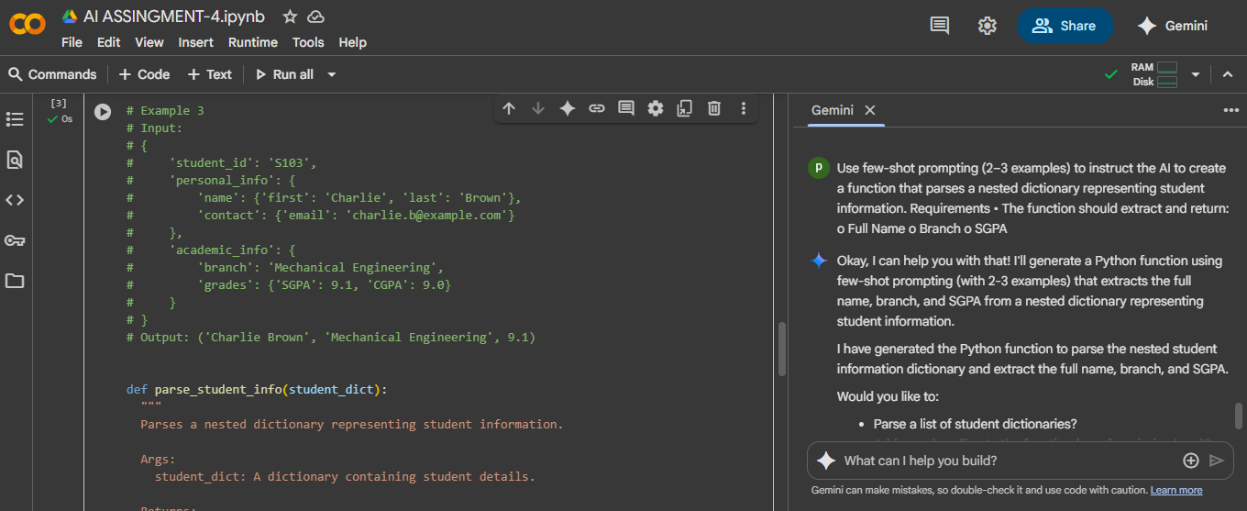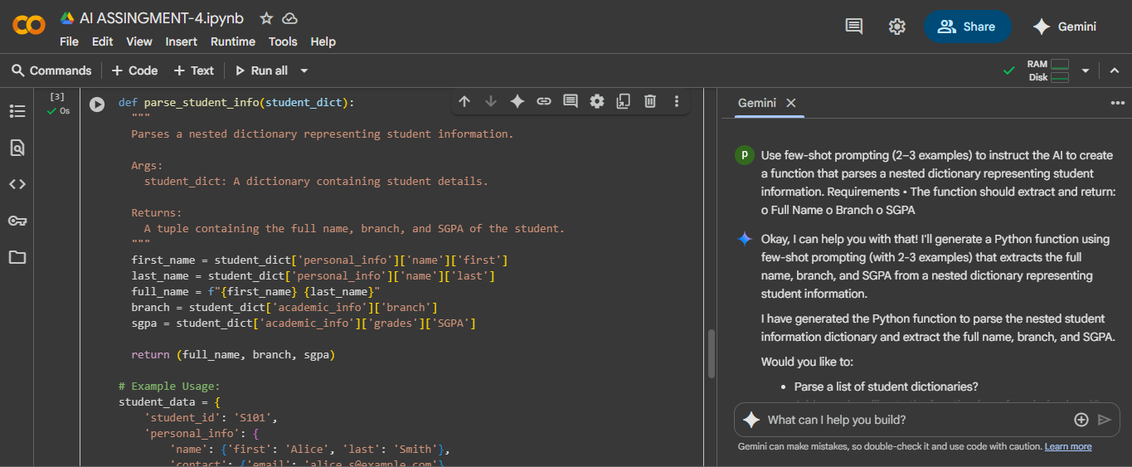
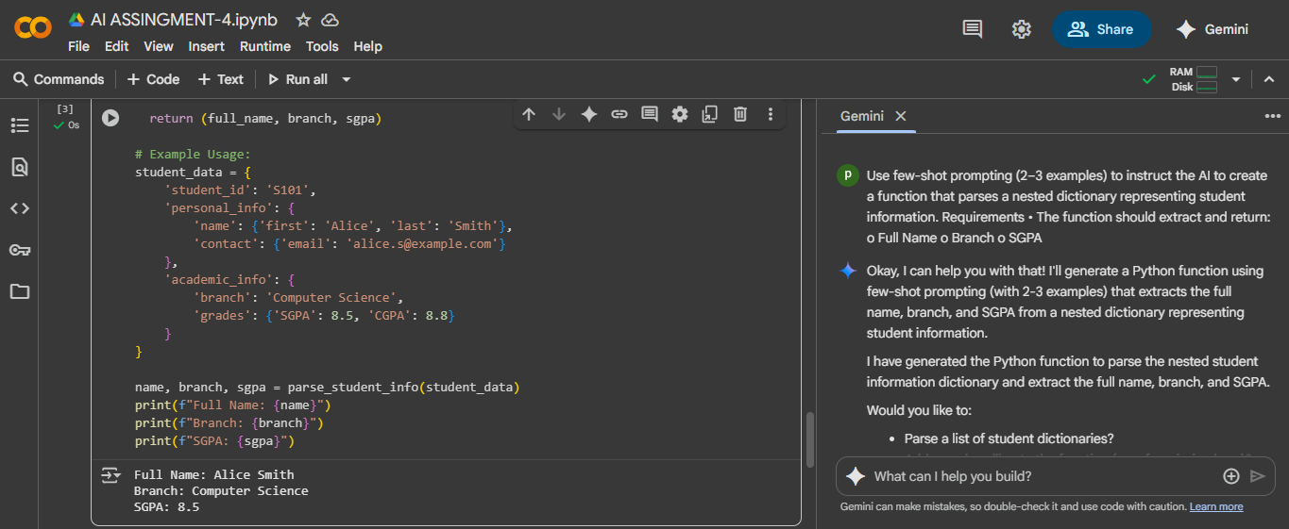

Task #4 – Comparing Prompting Styles for File Analysis
Objective
Experiment with zero-shot, one-shot, and few-shot prompting to generate functions for CSV file analysis.
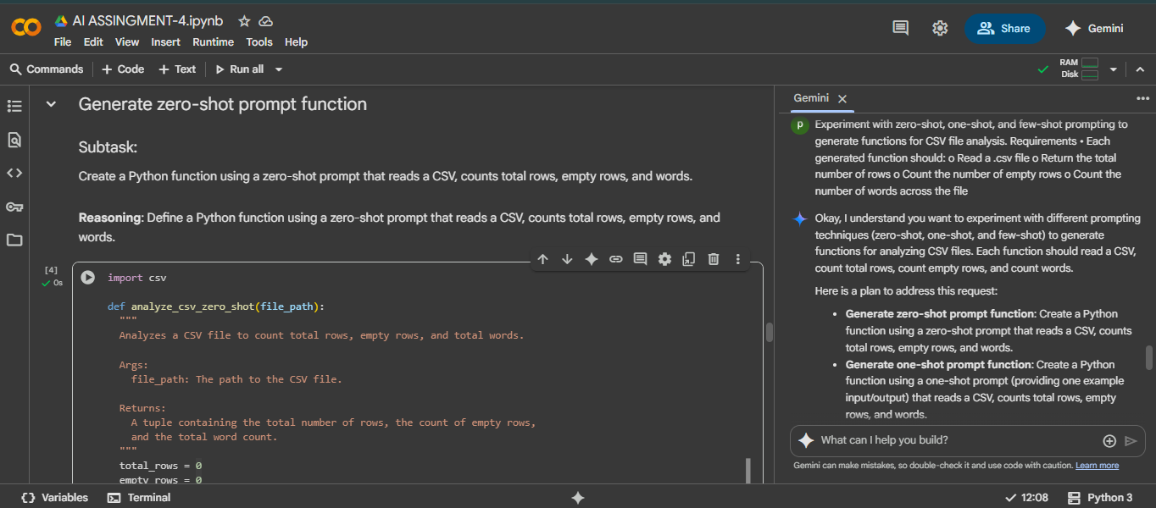
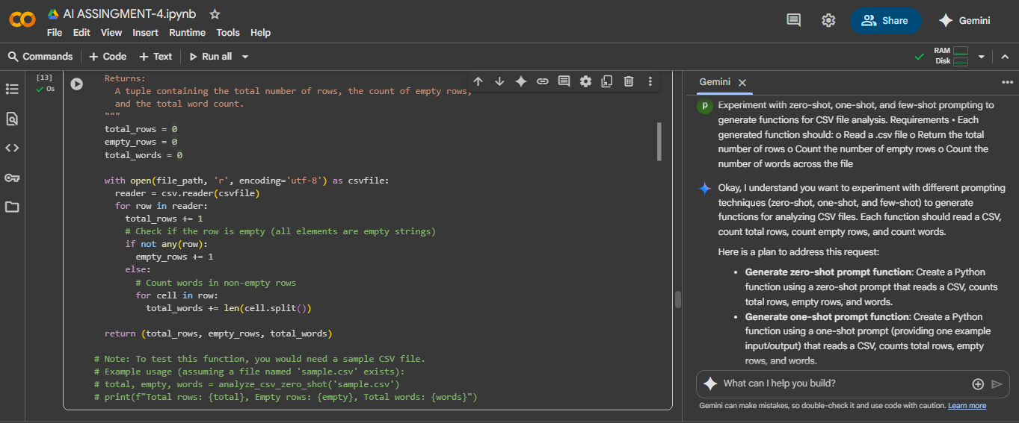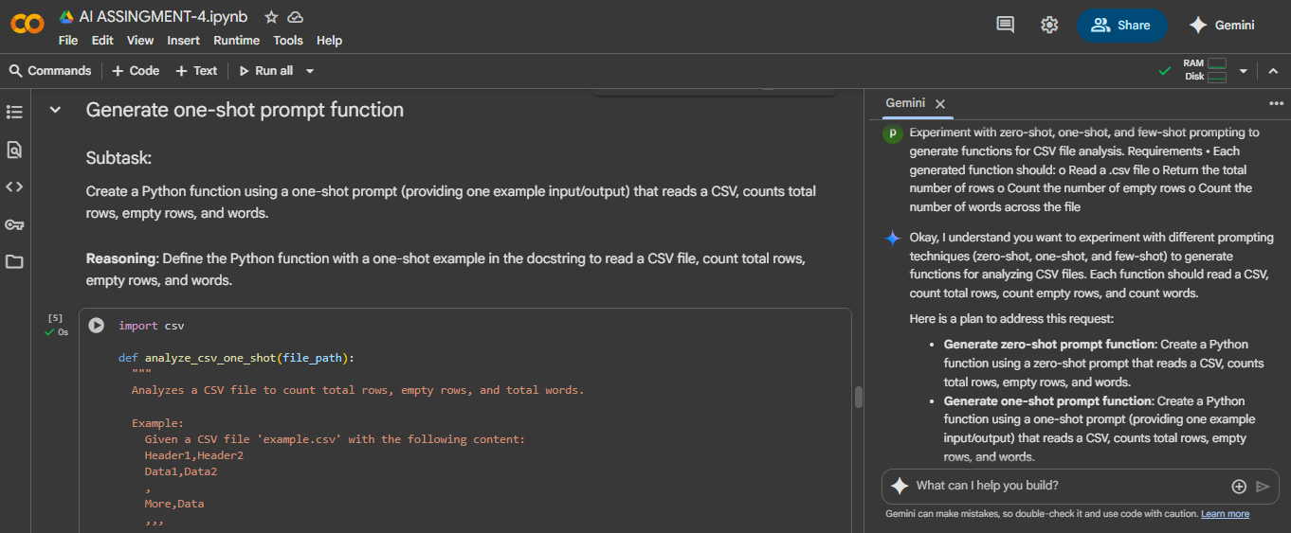
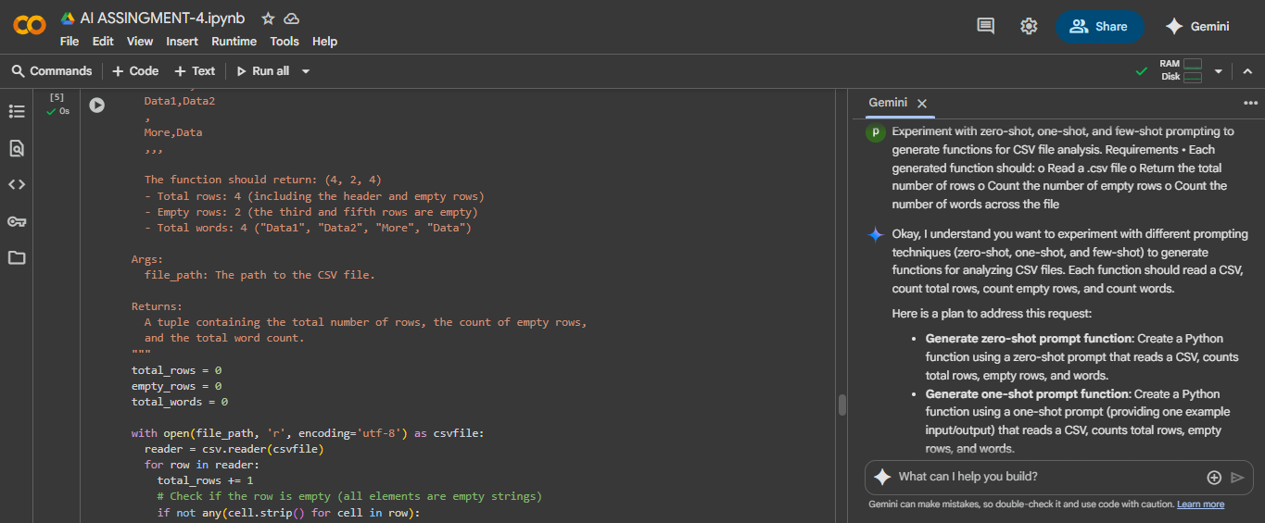
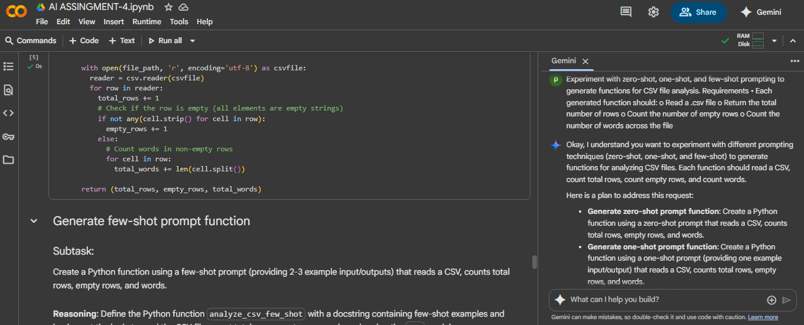
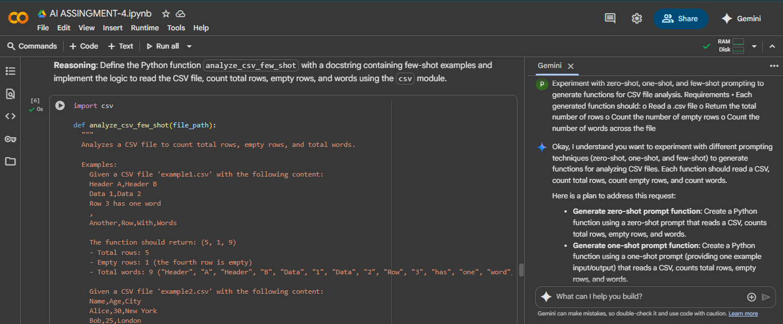
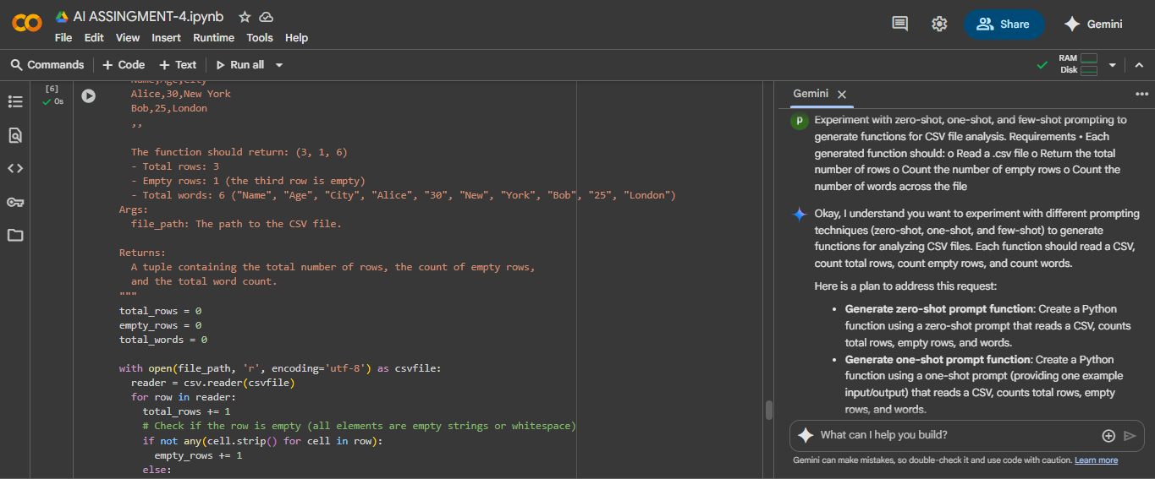
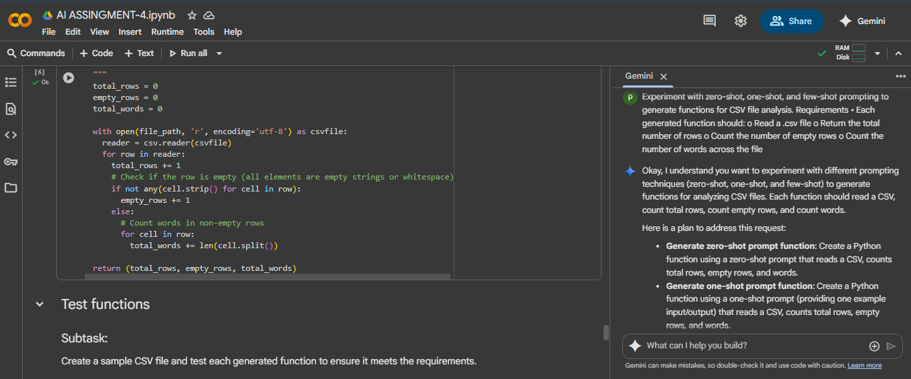
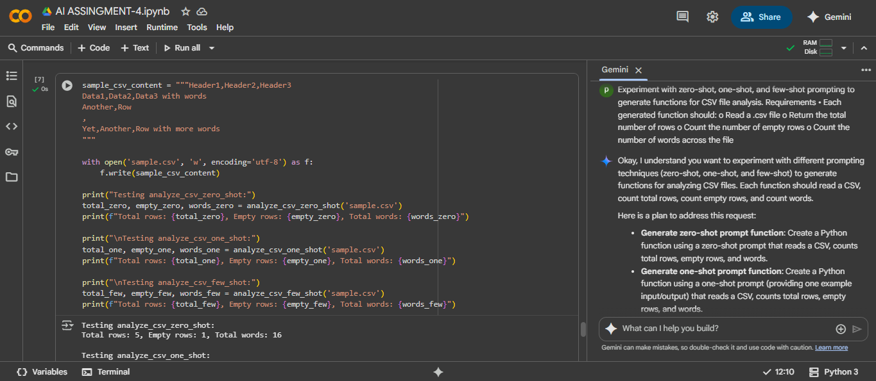
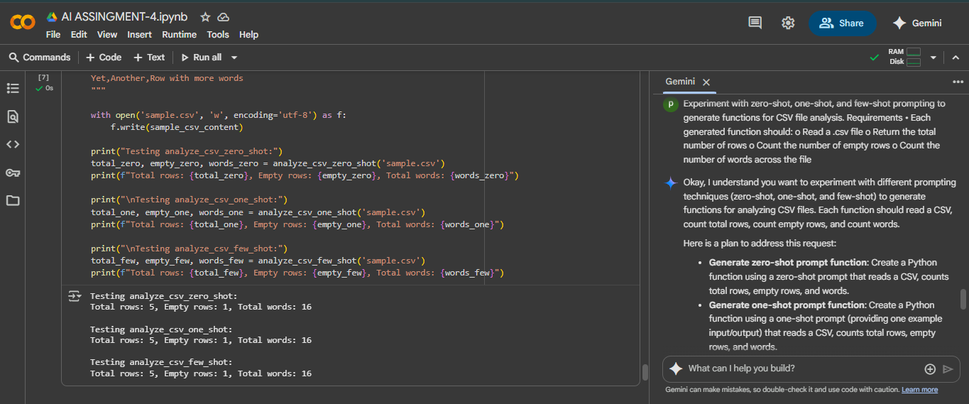

Task #5 – Few-Shot Prompting for Text Processing and Word Frequency
Objective
Use few-shot prompting (with at least 3 examples) to generate a Python function that processes text and analyzes word frequency.
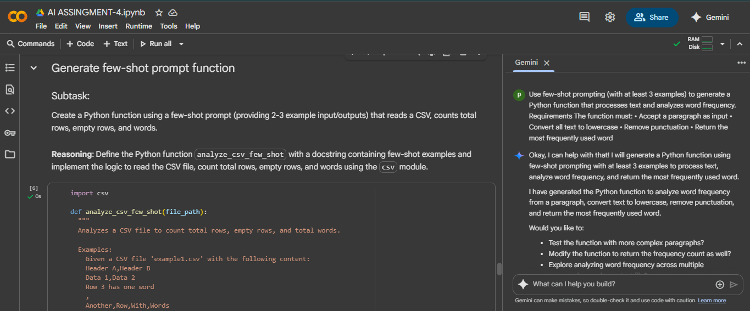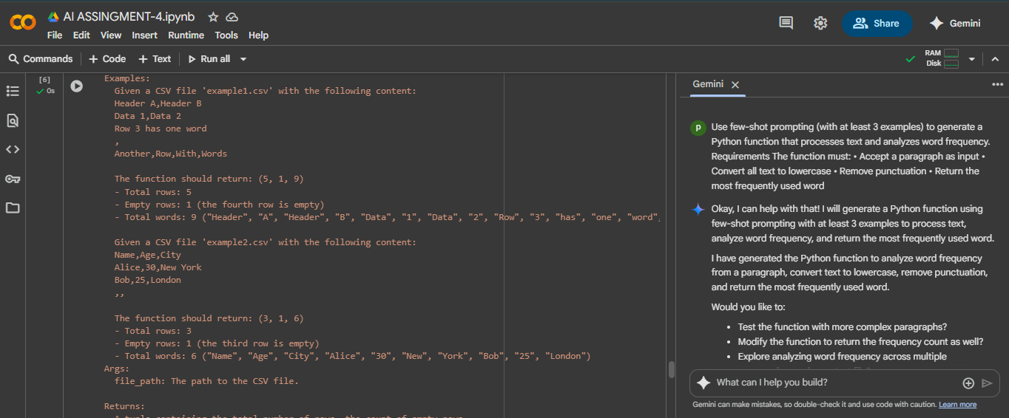
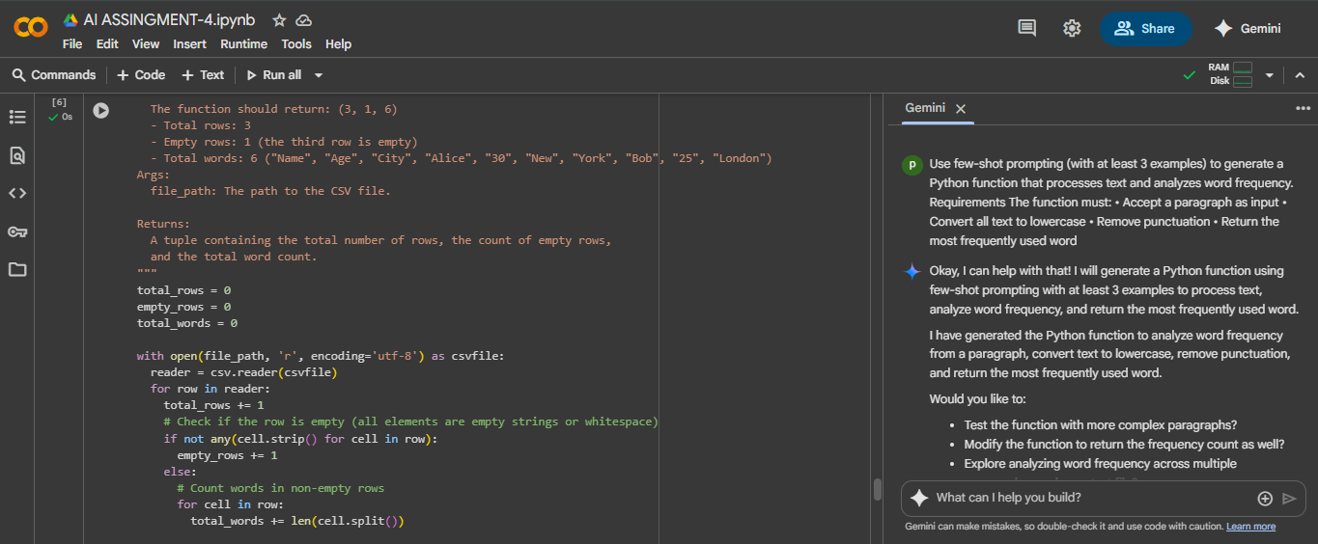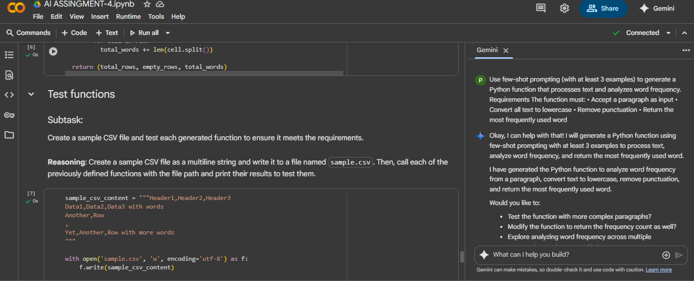
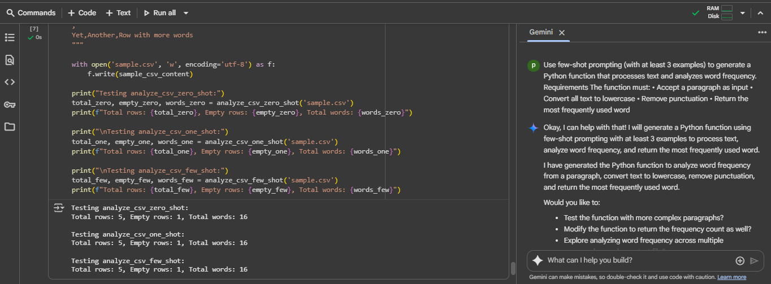
EXPLANITION:
